# Invitation Letter

30/05/2024

Name: Yixin Wang

Address: 578-584 Pacific Highway, Killara, 2071

ID card No.: 410603200410014523

Tel: +61 0451541917

Email: [yx.yixinw@gmail.com](mailto:yx.yixinw@gmail.com)

To: Visa office of Australian Embassy, China

Dear Sir/Madam,

My name is Yixin Wang (Passport No.EJ3385036), I am a student at the University of Sydney. I would like to invite my friend Yipu Du (Passport No.EK8532014) to visit me from 22nd July to 10th August in Australia. She is a student at Fujian Jiangxia University.

The main purpose of this letter is to invite my friend to travel in Australia.

We will probably go to the Sydney Opera House, the city center, the University of Sydney and other famous tourist attractions.

All the expenses during her visit in Australia will be covered by her parents including round-trip airfares, local transportation, insurance, recreation, and any other expenses that may occur. As for accommodation, she will probably live with me. My family live in an apartment. (578-584 Pacific Highway)

I will make sure that she complies with local laws and leaves Australia before the expiration of her visa.

Your kind and favorable consideration regarding her visa application will be highly appreciated. If you have any further questions, please contact me by telephone or email.

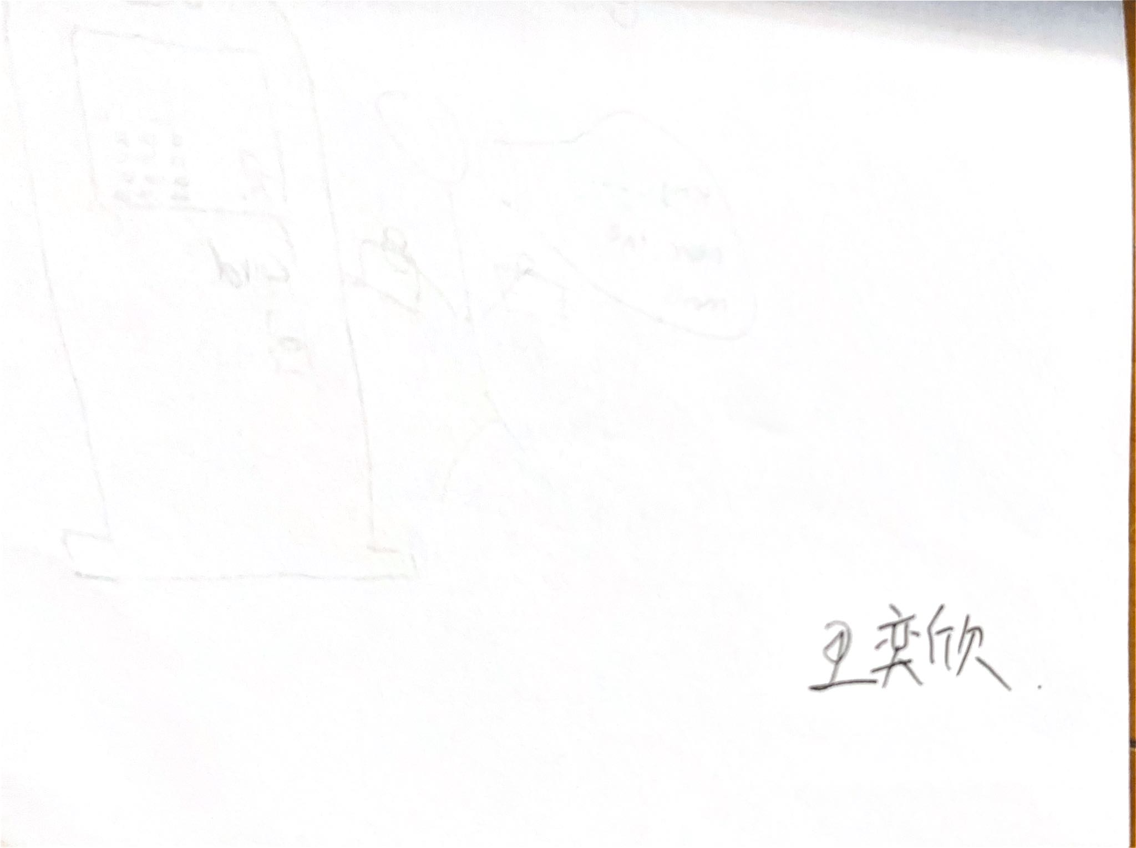

Yours Sincerely

Yixin Wang